
TB Button for COB
Requirements Specification Document
WR # 6357

Prepared by: Bimal Beura
Last updated Date: 2nd March 2010

Approved By:

______________________
Anthony Montesano
Trading Operations Division

______________________
Mark Novak
Systems Division

Draft Version
CBOE Confidential & Proprietary

Table of Contents
1 Introduction 3
1.1 Background 3
1.2 Purpose & Scope of this document 3
2 Requirement Analysis – TB Button for COB 3
2.1 Business Requirements 3
2.1.1 New Functionality 3
2.1.2 PAR 3
2.1.3 CBOEdirect 4
2.1.3.1 General Trading Rule 4
2.1.3.2 COA and TB Button 4
2.1.3.3 TA and TB Button for BOB classes in presence of Manual Quote 5
2.1.3.4 TB for simple order during Auction 5
2.1.4 TB Button for Cross Product Spread 5
2.2 Performance - Open 5
2.3 Roll Out Plan - Open 5
2.4 Business Process Flow 5
3 Assumptions 7
4 Risk 7
5 Appendix 7
5.1 Scenarios 7
5.1.1 TB button activation when all conditions fulfilled 7
5.1.2 TB button not activated when Customer order in COB not marketable with PAR order. 8
5.1.3 TB button not activated when Customer order in COB worse than DSM 8
5.1.4 TB button not activated when Leg market has customer interest on BBO on all legs 9
5.1.5 TB button not activated when only professional orders in COB marketable with PAR order. 9
5.1.6 No Trade at CBOEdirect using TB button from PAR if Customer is not on top of the book anymore 10
5.1.7 No Trade at CBOEdirect using TB button from PAR if Customer is at worse price than leg BBO as leg BBO changes 11
5.1.8 Partial Trade at CBOEdirect using TB button from PAR 12
5.1.9 Opposite order with TB when COA is ongoing for professional order 13
5.1.10 Same side better order with TB when COA is ongoing for an order 13
5.1.11 Trade with TA from PAR in presence of manual quote in book 14
5.1.12 Trade with TB from PAR in presence of manual quote in book 15
5.1.13 Opposite simple order with TB when Auction is ongoing for professional simple order 16
5.2 Open Issues/Questions 17

Introduction

Background
The goal of the system changes for this project is allow the floor brokers to be able to trade the public customer (‘C’ origin) COB, and without first trading with the legs of the complex order if they are at the same price points. As per the rules of CBOE, complex orders are allowed to trade in open outcry at the same net price as legs as long as there is no customer interest on the COB or all the legs of BBO at the execution price or better. If there is customer interest at the BBO on all the legs, then the floor broker must trade with all that customer interest on the top of the individual book at the same price, using the TA button, before trading the spread product in the open outcry. If COB has orders at the same price as leg, legs are given priority. So this enhancement allows brokers to trade customer COB orders while at the same price as the legs. This will enable the floor broker to trade with the COB, if the COB price is equal to or better than the leg BBO prices.

Purpose & Scope of this document
This document presents the results of business requirements gathering and analysis for the TB Button for COB project. The work involved:

- Requirement Gathering and Analysis
- Documenting the business requirements in the prescribed format

It describes the rollout implications and non-functional requirements that include the performance, the time constraints and monitoring & back up/recovery.

Requirement Analysis – TB Button for COB

Business Requirements

New Functionality
TB Button will be enabled for complex orders on PAR, under certain circumstances. Currently TB button is disabled for complex orders.

PAR
There will be modification to the existing PAR functionality.
- Currently, TB button is enabled only for simple orders. Now as a part of this project, TB Button will be activated for Complex Orders , under the following circumstances:
  - When a customer order resting on top of the COB is marketable with the PAR order at PAR and
  - The price of the customer order resting in COB is equal to or better than the DSM based on Leg prices and
  - If the customer COB is at the SAME price as the DSM, leg Market does not have customer interest on BBO on ALL the legs
- TB Button will not be activated if there are only Professional orders in the COB, even if these orders are marketable with PAR order.
- TB button should be activated for BOB classes also if all the checks are passed, even if manual quotes exist on the individual leg BBOs.
- PAR user needs to see the breakdown between customer and professional interest in the COB, so the activation of TB button will be decided based on it. PAR will subscribe to MDX for each product connected to an order on PAR. The MDX data includes a breakdown between customer and professional interest in the COB. PAR user will be able to see the details of the breakdown for complex orders the way it happens for simple orders.
- Once activated TB Button should not be deactivated while the PAR ticket is open, even if the COB or DSM changes. So, it is possible for the trade engine to fail the TB attempt.

CBOEdirect

General Trading Rule
- When an order is sent to CBOEdirect from PAR using the TB button, it will trade with the customer order resting in the COB if ALL the following conditions are met
  - The price of the customer order resting in COB is equal to or better than the DSM based on Leg BBO prices
  - If the customer COB order is at the SAME price as the DSM, leg Market does not have customer interest on BBO on ALL the legs
  - The customer order is at the top of the COB (i.e. there are no non-cust COB orders at a better price)
- The order sent to CBOEdirect from PAR using TB button will only trade with the customer interest in the COB. If customer order and professional orders are at the top of book together, the order from PAR would trade with customer interest only.
- When an order is sent to CBOEdirect from PAR using TB button and if the customer COB order is not better than or equal to DSM based on leg BBO now, as leg market has moved to a better price, then it will be returned back to PAR by Hybrid Trade Server.
- When an order is sent to CBOEdirect from PAR using TB button and if the customer COB order is not on the top of the book now as a better priced professional order has arrived, then it will be returned back to PAR by Hybrid Trade Server.
- When PAR receives the order back from HTS, for activating TB button for the returned order it has to check all the conditions like it checks for a new order.
- When an order is sent to CBOEdirect from PAR using the TB button, after the trade at CBOEdirect, the remainder, if any, will route back to the originating PAR.
- The trade allocation will use the configured COB allocation algorithm.

COA and TB Button
- During an ongoing COA for a Professional complex order which is at a better price than resting customer order in same side, if an OPPOSITE side order is sent from PAR using TB button which is marketable with both the same side orders – TB button should fail and the order should return to PAR. COA auction for professional complex order should be unaffected.
- During the COA for a Customer or Professional order, if a SAME side order is sent from PAR with TB button which is marketable with opposite side COB order – It should end the auction prematurely and auctioned order will be given first preference in trading allocations.

TA and TB Button for BOB classes in presence of Manual Quote

- TA –
  - If a complex order is sent from PAR with TA button, it should be able to trade with resting customer order only when Manual quotes are resting at the SAME price points as quotes or orders. Even if “Auto ex size against Non Customer” is non-zero, still the order with TA should not be traded with quote when the quote is aggregated with manual quote.
  - If Manual quotes are at better price, then complex order sent with TA button from PAR should NOT be allowed to trade through Manual quote and order will return to PAR.
- TB –
  - If a complex order is sent from PAR with TB button, it should be able to trade with marketable resting customer orders in the COB when Manual quotes are resting at the SAME price point on Legs.
  - If Manual quotes are at better price, then the complex order sent with TB button from PAR should NOT be allowed to trade through Manual quote and order will return to PAR.
That says TA and TB button for BOB classes would behave exactly the same in presence of manual quotes.

TB for simple order during Auction
During an ongoing auction for a Professional simple order which is at a better price than resting customer order in same side, if an OPPOSITE side simple order is sent from PAR using TB button which is marketable with both the same side orders – TB button should fail and the order should return to PAR. Auction for the professional order should NOT be affected.

TB Button for Cross Product Spread
TB button should be enabled for Cross Product Spread orders. It should function the same way like it does for complex orders. Adjusted DQ should be used for all the trading decisions in CBOEdirect. The customer order in the COB has to fulfill all the trading conditions along with the condition that it should be at or better than Adjusted DQ to be able to trade with the order sent from PAR using TB button.

Performance - Open

Roll Out Plan - Open

Business Process Flow

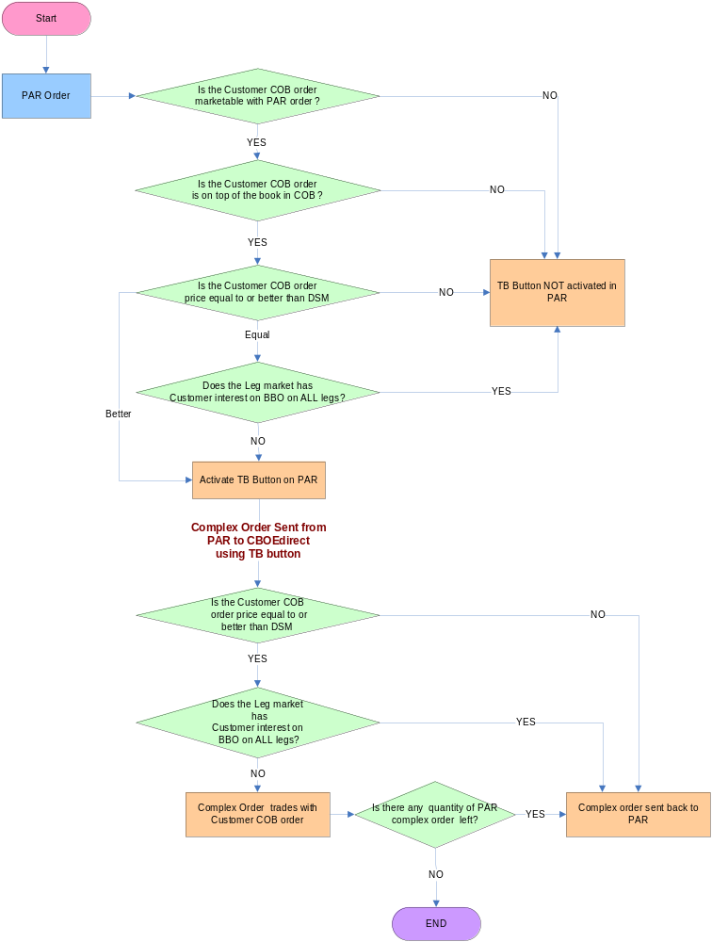

Assumptions

- The existing TA functionality can be used to clear the customer interest in the legs when there is customer interest on all of the legs as well as the professional interest in the COB

Risk
- Medium risk – This project is medium size and spans several systems groups.

Appendix

Scenarios

TB button activation when all conditions fulfilled

Step # | Action / Result
1 | CBOE Option Leg1 is 1.00 – 1.20 (100 x 100)  CBOE Option Leg2 is 1.00 – 1.20 (100 x 100)  DSM +0.20 / +0.20  Book Depth – Leg1 - 1.00 – 1.20 (100 x 100)  Leg2 - 1.00 – 1.20 (100 x 100)
2 | Incoming Customer Complex Order ORD1  Same 100 @ -0.15  COA starts @ -0.15; After COA the order is booked.  COB : Defined 100 @ -0.15
3 | Incoming Complex Order ORD2, Direct Route to “PAR”  Opposite 100 @ +0.15  Order should be found in desired PAR work station
4 | TB Button is activated now at PAR.
5 | ORD2 sent from PAR to CBOEdirect using TB Button.  ORD2 trades with ORD1 @ 0.15

TB button not activated when Customer order in COB not marketable with PAR order.

Step # | Action / Result
1 | CBOE Option Leg1 is 1.00 – 1.20 (100 x 100)  CBOE Option Leg2 is 1.00 – 1.20 (100 x 100)  DSM +0.20 / +0.20  Book Depth – Leg1 - 1.00 – 1.20 (100 x 100)  Leg2 - 1.00 – 1.20 (100 x 100)
2 | Incoming Customer Complex Order ORD1  Same 100 @ -0.10  COA starts @ -0.10; After COA the order is booked.  COB : Defined 100 @ -0.10
3 | Incoming Complex Order ORD2, Direct Route to “PAR”  Opposite 100 @ +0.15  Order should be found in desired PAR work station
4 | TB Button is not activated now as ORD1 is not marketable with ORD2.

TB button not activated when Customer order in COB worse than DSM

Step # | Action / Result
1 | CBOE Option Leg1 is 1.00 – 1.20 (100 x 100)  CBOE Option Leg2 is 1.00 – 1.20 (100 x 100)  DSM +0.20 / +0.20  Book Depth – Leg1 - 1.00 – 1.20 (100 x 100)  Leg2 - 1.00 – 1.20 (100 x 100)
2 | Incoming Customer Complex Order ORD1  Same 100 @ +0.25. Order is booked  COB : Defined 100 @ +0.25
3 | Incoming Complex Order ORD2, Direct Route to “PAR”  Opposite 100 @ -0.25  Order should be found in desired PAR work station
4 | TB Button is not activated now as ORD1 is worse than DSM even if it is marketable with PAR order ORD2.

TB button not activated when Leg market has customer interest on BBO on all legs
Step # | Action / Result
1 | CBOE Option Leg1 is 1.00 – 1.20 (100 x 100)  CBOE Option Leg2 is 1.00 – 1.20 (100 x 100)  DSM +0.20 / +0.20  Incoming C order on Leg1 Sell 100 @ 1.20  Incoming C order on Leg2 Buy 100 @ 1.00  Book Depth – Leg1 - 1.00 – 1.20 (100 x 200)  Leg2 - 1.00 – 1.20 (200 x 100)
2 | Incoming Customer Complex Order ORD1  Same 100 @ +0.20  The order is booked.  COB : Defined 100 @ +0.20
3 | Incoming Complex Order ORD2, Direct Route to “PAR”  Opposite 100 @ -0.20  Order should be found in desired PAR work station
4 | TB Button is not activated now as Leg BBO has customer interest on ALL legs

TB button not activated when only professional orders in COB marketable with PAR order.

Step # | Action / Result
1 | CBOE Option Leg1 is 1.00 – 1.20 (100 x 100)  CBOE Option Leg2 is 1.00 – 1.20 (100 x 100)  DSM +0.20 / +0.20  Book Depth – Leg1 - 1.00 – 1.20 (100 x 100)  Leg2 - 1.00 – 1.20 (100 x 100)
2 | Incoming Customer Complex Order ORD1  Same 100 @ -0.10  COA starts @ -0.10; After COA the order is booked.  Incoming W Origin Complex Order ORD2  Same 100 @ -0.15  COA starts @ -0.15; After COA the order is booked.  COB : Defined 100 @ -0.15  Defined 100 @ -0.10
3 | Incoming Complex Order ORD3, Direct Route to “PAR”  Opposite 100 @ +0.15  Order should be found in desired PAR work station
4 | TB Button is not activated now as ORD1 is not marketable with ORD2 although ORD1 is marketable with ORD3.

No Trade at CBOEdirect using TB button from PAR if Customer is not on top of the book anymore

Step # | Action / Result
1 | CBOE Option Leg1 is 1.00 – 1.20 (100 x 100)  CBOE Option Leg2 is 1.00 – 1.20 (100 x 100)  DSM +0.20 / +0.20  Book Depth – Leg1 - 1.00 – 1.20 (100 x 100)  Leg2 - 1.00 – 1.20 (100 x 100)
2 | Incoming Customer Complex Order ORD1  Same 100 @ -0.10  COA starts @ -0.10; After COA the order is booked.  COB : Defined 100 @ -0.10
3 | Incoming Complex Order ORD2, Direct Route to “PAR”  Opposite 100 @ +0.10  Order should be found in desired PAR work station
4 | TB Button is activated now at PAR.
5 | Incoming “W” Complex Order ORD3  Same 100 @ -0.15  COA starts @ -0.15; After COA the order is booked at CBOEdirect.  COB : Defined 100 @ -0.15  Defined 100 @ -0.10
6 | ORD2 sent from PAR to CBOEdirect using TB Button.  No Trade happen as W order is top of the in COB.  HyTS sends ORD2 back to PAR.

No Trade at CBOEdirect using TB button from PAR if Customer is at worse price than leg BBO as leg BBO changes

Step # | Action / Result
1 | CBOE Option Leg1 is 1.00 – 1.20 (100 x 100)  CBOE Option Leg2 is 1.00 – 1.20 (100 x 100)  DSM +0.20 / +0.20  Book Depth – Leg1 - 1.00 – 1.20 (100 x 100)  Leg2 - 1.00 – 1.20 (100 x 100)
2 | Incoming Customer Complex Order ORD1  Same 100 @ +0.20  The order is booked.  COB : Defined 100 @ +0.20
3 | Incoming Complex Order ORD2, Direct Route to “PAR”  Opposite 100 @ -0.20  Order should be found in desired PAR work station
4 | TB Button is activated now at PAR.
5 | Leg 1 quote is updated to 1.00 – 1.15 (100 x 100)  DSM +0.15 / +0.20  COB : Defined 100 @ +0.20
6 | ORD2 sent from PAR to CBOEdirect using TB Button.  No Trade happen as Customer order price is worse than DSM on the same side.  HyTS sends ORD2 back to PAR.

Partial Trade at CBOEdirect using TB button from PAR

Step # | Action / Result
1 | CBOE Option Leg1 is 1.00 – 1.20 (100 x 100)  CBOE Option Leg2 is 1.00 – 1.20 (100 x 100)  DSM +0.20 / +0.20  Book Depth – Leg1 - 1.00 – 1.20 (100 x 100)  Leg2 - 1.00 – 1.20 (100 x 100)
2 | Incoming Customer Complex Order ORD1  Same 50 @ -0.15  COA starts @ -0.15; After COA the order is booked.  COB : Defined 50 @ -0.15
3 | Incoming Complex Order ORD2, Direct Route to “PAR”  Opposite 100 @ +0.15  Order should be found in desired PAR work station
4 | TB Button is activated now at PAR.
5 | ORD2 sent from PAR to CBOEdirect using TB Button.  ORD2 trades with ORD1 50 @ 0.15  Reminder 50 of ORD2 routed back to PAR.

Opposite order with TB when COA is ongoing for professional order

Step # | Action / Result
1 | CBOE Option Leg1 is 1.00 – 1.20 (100 x 100)  CBOE Option Leg2 is 1.00 – 1.20 (100 x 100)  DSM +0.20 / +0.20  Book Depth – Leg1 - 1.00 – 1.20 (100 x 100)  Leg2 - 1.00 – 1.20 (100 x 100)
2 | Incoming Customer Complex Order ORD1  Same 50 “C” origin @ -0.10  COA starts @ -0.10; After COA the order is booked.  COB : Defined 50 @ -0.10
3 | Incoming Complex Order ORD2, Direct Route to “PAR”  Opposite 100 @ +0.10  Order should be found in desired PAR work station  TB Button is activated now at PAR
4 | Incoming Complex professional Order ORD3  Same 50 “M” origin @ -0.15  COA starts @ -0.15
5 | ORD2 sent from PAR to CBOEdirect using TB Button while COA is going on for ORD3  TB button will fail and ORD2 routed back to PAR as professional order is better priced than customer order on same side.

Same side better order with TB when COA is ongoing for an order

Step # | Action / Result
1 | CBOE Option Leg1 is 1.00 – 1.20 (100 x 100)  CBOE Option Leg2 is 1.00 – 1.20 (100 x 100)  DSM +0.20 / +0.20  Book Depth – Leg1 - 1.00 – 1.20 (100 x 100)  Leg2 - 1.00 – 1.20 (100 x 100)
2 | Incoming Customer Complex Order ORD1  Same 50 “C” origin @ -0.10  COA starts @ -0.10; After COA the order is booked.  COB : Defined 50 @ -0.10
3 | Incoming Complex Order ORD2, Direct Route to “PAR”  Opposite 100 @ +0.10  Order should be found in desired PAR work station  TB Button is activated now at PAR
4 | Incoming Complex professional Order ORD3  Opposite 50 “M” origin @ +0.15  COA starts @ 0.15
5 | ORD2 sent from PAR to CBOEdirect using TB Button while COA is going on for ORD3  Auction will end prematurely and ORD2 trades with ORD1 for 50 qty. Remaining ORD2 routed back to PAR. ORD3 is booked.  COB : Opposite 50 @ 0.15

Trade with TA from PAR in presence of manual quote in book

Step # | Action / Result
1 | CBOE Option Leg1 is 1.00 – 1.20 (100 x 100)  CBOE Option Leg2 is 1.00 – 1.20 (100 x 100)  DSM +0.20 / +0.20  Book Depth – Leg1 - 1.00 – 1.20 (100 x 100)  Leg2 - 1.00 – 1.20 (100 x 100)
2 | Incoming Manual quote Ask 100@1.20 on Leg 1  Incoming Manual quote Bid 100@1.00 on Leg 2  Book Depth – Leg1 - 1.00 – 1.20 (100 x 200)  Leg2 - 1.00 – 1.20 (200 x 100)
3 | Incoming Customer Complex Order ORD1  Opposite 50 “C” origin @ +0.20  ORD1 is booked.  COB : Opposite 50 @ +0.20
4 | Incoming Customer Complex Order ORD2  Same 200 “C” origin @ -0.20 Direct Route to “PAR”  Order should be found in desired PAR work station
5 | ORD2 sent from PAR to CBOEdirect using TA Button
6 | ORD2 trades only with ORD1 for 50 qty.  Remaining 150 qty of ORD2 routed back to PAR.

Trade with TB from PAR in presence of manual quote in book

Step # | Action / Result
1 | CBOE Option Leg1 is 1.00 – 1.20 (100 x 100)  CBOE Option Leg2 is 1.00 – 1.20 (100 x 100)  DSM +0.20 / +0.20  Book Depth – Leg1 - 1.00 – 1.20 (100 x 100)  Leg2 - 1.00 – 1.20 (100 x 100)
2 | Incoming Manual quote Ask 100@1.20 on Leg 1  Incoming Manual quote Bid 100@1.00 on Leg 2  Book Depth – Leg1 - 1.00 – 1.20 (100 x 200)  Leg2 - 1.00 – 1.20 (200 x 100)
3 | Incoming Customer Complex Order ORD1  Opposite 50 “C” origin @ +0.20  ORD1 is booked.  COB : Opposite 50 @ +0.20
4 | Incoming Customer Complex Order ORD2  Same 200 “C” origin @ -0.20 Direct Route to “PAR”  Order should be found in desired PAR work station
5 | ORD2 sent from PAR to CBOEdirect using TB Button
6 | ORD2 trades with ORD1 for 50 qty.  Remaining 150 qty of ORD2 routed back to PAR.

Opposite simple order with TB when Auction is ongoing for professional simple order

Step # | Action / Result
1 | CBOE Option Leg1 is 1.00 – 1.20 (100 x 100)  Book Depth – Leg1 - 1.00 – 1.20 (100 x 100)
2 | Incoming Customer Order ORD1  Buy 50 “C” origin @ 1.10  HAL starts @ -0.10; After HAL the order is booked.  Current Market 1.10 – 1.20 (50 x 100)
3 | Incoming Order ORD2, Direct Route to “PAR”  Sell 100 @ 1.10  Order should be found in desired PAR work station
4 | Incoming professional Order ORD3  Buy 50 “M” origin @ 1.15  HAL starts @ 1.15
5 | ORD2 sent from PAR to CBOEdirect using TB Button while HAL is going on for ORD3  TB button will fail and ORD2 routed back to PAR as professional order is better priced than customer order on same side.

Open Issues/Questions

Topic Related to | Issue Description
Rollout | How are we going to rollout the new functionality TB button for COB?
Performance | Does the introduction of the new functionality going to have any major impact in the performance of the existing system? Any specific performance testing needs to be done?

